Jobing title

# ERD for UX process

Place your ERD diagram here.

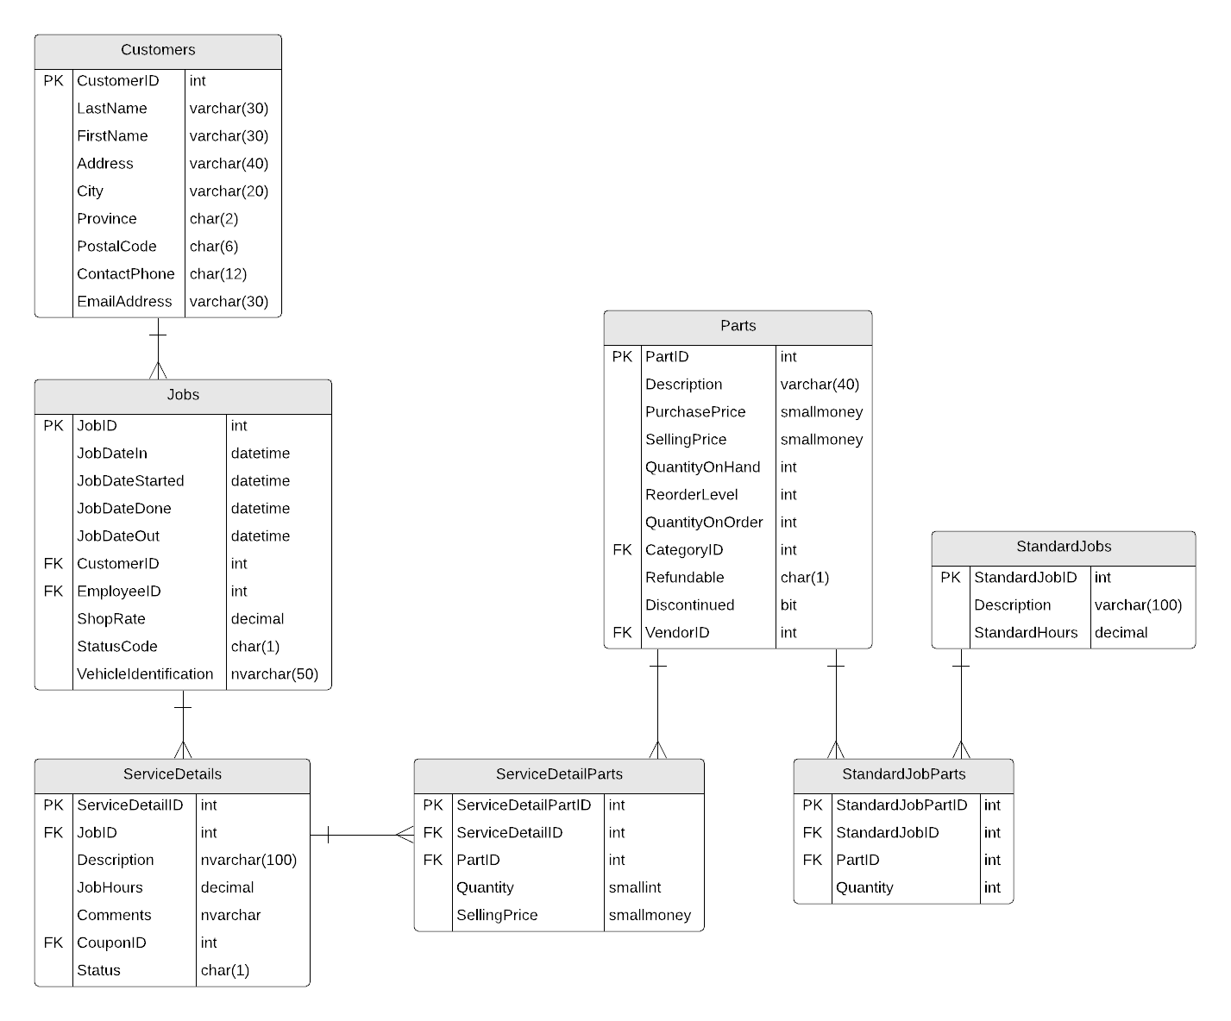

# Possible UX Interface

Place your screen design(s) here

|  |  |  |
| --- | --- | --- |
| **Controls** | | **Events** |
| control name | | web page event or ODS message |
| **BBL Class(es) and Method (s)** | | |
| controller name | method header  statement about the method’s purpose. may include inputs and outputs | |
| **SQL Table(s): (C,R,U,D)** | | **Entities/DTOs/POCOs** |
| name of sql table involved and access | | name of any new DTO or POCO class |

# Event and Wiring Summations

# Samples

|  |  |  |
| --- | --- | --- |
| **Controls** | | **Events** |
| Fetch (Artist, MediaType, Genre, Album),  Tracks, TracksBy, SearchArgID | | OnClick / wired via ObjectDataSource   * Move selection value to TracksBy, DDL id to SearchArgID; * Bind data to Tracks |
| **BBL Class(es) and Method (s)** | | |
| TracksController | List<TrackList> List_TracksForPlaylistSelection(string tracksby, int argid)  Retrieve a list of tracks for supplied selection type and argument id. Return trackid, title, timelength, unitprice. Display in Tracks. | |
| **SQL Table(s): (C,R,U,D)** | | **Entities/DTOs/POCOs** |
| Tracks (R) | | TrackList (P) |

|  |  |  |
| --- | --- | --- |
| **Controls** | | **Events** |
| Fetch (PlayList), Playlist, PlayListName | | Fetch OnClick   * Validate data present; * call BLL; * Bind returned data to PlayList. |
| **BBL Class(es) and Method (s)** | | |
| PlaylistTracksController | List< UserPlaylistTrack > List_TracksForPlaylist(string playlistname, string username)  Retrieve a list of tracks for supplied playlist name and username. Return trackid, title, timelength, unitprice, tracknumber. Display in PlayList. | |
| **SQL Table(s): (C,R,U,D)** | | **Entities/DTOs/POCOs** |
| PlayList (R), PlaylistTracks(R) | | UserPlaylistTrack (P) |

|  |  |  |
| --- | --- | --- |
| **Controls** | | **Events** |
| CustomerDDL | | Wired via ODS |
| **BBL Class(es) and Method (s)** | | |
| CustomerController | List <CustomerList> newCustomerList()   * Generate the customer List * Select a customer | |
| **SQL Table(s): (C,R,U,D)** | | **Entities/DTOs/POCOs** |
| Customers(R) | | CustomerList (P) |

**NEW JOB LIST**

|  |  |  |
| --- | --- | --- |
| **Controls** | | **Events** |
| CustomerDDL | | Wired via ODS |
| **BBL Class(es) and Method (s)** | | |
| CustomerController | List <CustomerList> newCustomerList()   * Generate the customer List * Select a customer | |
| **SQL Table(s): (C,R,U,D)** | | **Entities/DTOs/POCOs** |
| Customers(R) | | CustomerList (P) |

|  |  |  |
| --- | --- | --- |
| **Controls** | | **Events** |
| NewJob | | NewJob OnClick |
| **BBL Class(es) and Method (s)** | | |
| JobController | Void NewJob_Customer(string customername, string contactphone)   * Validate data present – customer is selected; * Error message: If no value is selected * Create Job ID * Parse Customer information to the new job page | |
| **SQL Table(s): (C,R,U,D)** | | **Entities/DTOs/POCOs** |
| Job (C) | | UserPlaylistTrack (P) |

|  |  |  |
| --- | --- | --- |
| **Controls** | | **Events** |
| View | | View OnClick |
| **BBL Class(es) and Method (s)** | | |
| JobController | Void NewJob_Customer(string customername, string contactphone)   * Validate data present – customer is selected; * Error message: If no value is selected * Create Job ID * Parse Customer information to the new job page | |
| **SQL Table(s): (C,R,U,D)** | | **Entities/DTOs/POCOs** |
| Job (C) | | UserPlaylistTrack (P) |